Typhoon No. 24
The large-sized and ultra-strong typhoon No. 24 is heading towards the South of Okinawa and moving slowly North on the 26th (as of 12:00).
While maintaining its force, typhoon No. 24 is heading towards the South of Okinawa then North with a slow speed, and will be heading North West tomorrow. There is a considerable possibility it will approach the Okinawa district on Sat., 29th.
The sea off Okinawa is already damp with the surge and waves will increase further tomorrow. On the main Okinawa island district and peninsular islands, it is likely to become a big storm. Please watch out for a surge in high waves. Moreover, as the typhoon heads North, an ultra-strong wind will blow on the peninsular islands, and a strong wind will blow on the main Okinawa island district tomorrow.

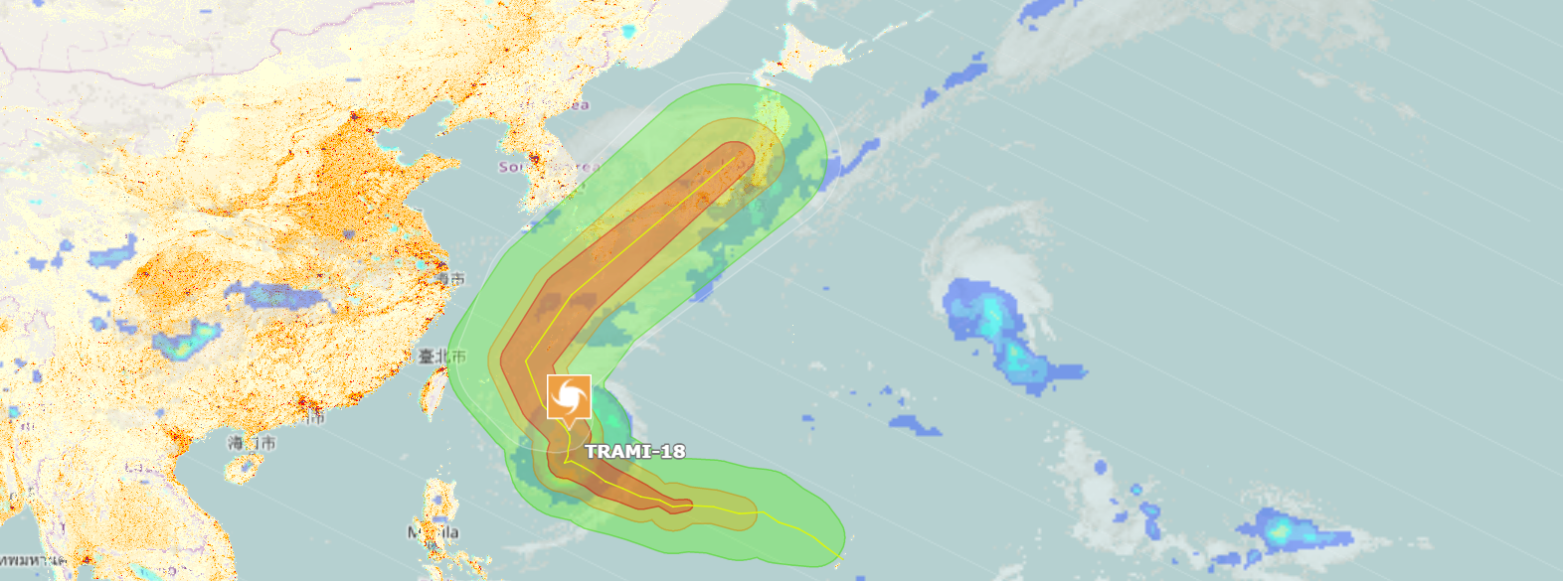

Be careful of a gale-force wind.
A careful watch is required since there is also a possibility that the effects of the typhoon may be prolonged as it heads slowly North. It is predicted that typhoon No. 24 will head North and hit the Japanese Islands.
It is predicted that typhoon No. 24 has the possibility of approaching the Amami district around Sunday, the 30th and approaching the western part of Japan at considerable speed. Then, it is likely to arrive in East Japan on Mon., October 1, after hitting the Japanese Islands.
There is a possibility of rough weather, such as heavy rain and a windstorm, over a wide area following the typhoon. Let's listen out for future typhoon reports and make early preparations for an upcoming typhoon.

